|  |  |  |
| --- | --- | --- |
|  | 1 |  |
|  |  |

Data Science Project Teachable Machine Learning

**Usama Saeed #7A**

**Roll No #BSEM-F16-137**

**Abstract**—Teachable Machine is a web based tool for creating custom machine learning classification models without specialized technical expertise. Machine Learning system learn to analyze datawithout being explicitly programmed. we created it to help students, Teachers, Designers ,and others learn about machine learning by creating and using their own classification models . its broad uptake suggests it has empowered people to leran , teach, and explore Machine Learning.

**1. Introduction**

in Machine learning we are so easily to achieve her goal due to this machine learning tool I have also make a project in machine learning tool. Firstly Gather Data in this project.

**Gather data**

Gather and Group your examples into classes or categories that you want to computer Learn.

**Train Model**

Train our model then instantly test it out to see whether it can correctly classify new examples.

**Export Model**

Export our model in our projects , sites ,apps and more we are export our model or code in github firstly create account in github and send our code on it.

In my project i have create Three classes Named Are First class Name images with **Laptop Adapter**

Next class is **Register** and Third class is with **Mobile charger**

**With Laptop Adapter**

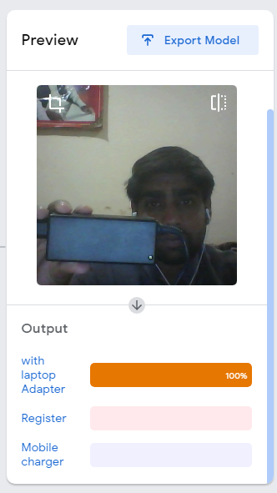

**With Register**

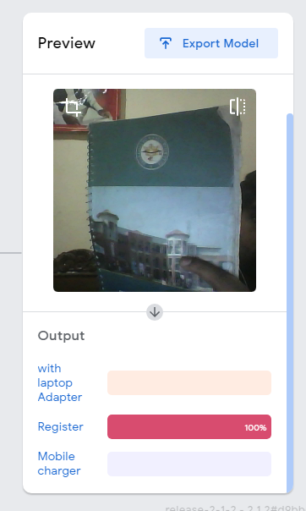

**With Mobile Charger**

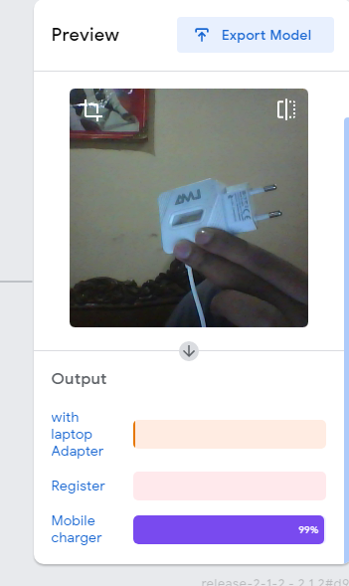

* **CONCLUSION**

In conclusion we have build our project firstly

Laptop Adapter in front of camera then result

is 100 on laptop Adapter Next Register in front

of camera then result is 100 on Register and

Next Mobile charger the result is 100 on mobile charger.

**Ist Result**



**2nd Result**



**3rd Result**

**ACKNOWLEDGMENTS**

All praises to ALLAH ALMIGHTY, the most Merciful and the most Gracious, for the strengths

and his blessings in completing this Project. Working on this project was so a difficult task that demanded large efforts. However, we tendto feel proud to specific our deepest sense of feeling and appreciation to our Teacher sir ***Dr. Arfan Jaffar*** for his kind facilitate advice, unlimited support, and sincere personal involvement throughout the event of project. We would ne'er be able to reach this stage except for the prayers and nice support of ourParents and Teachers.

**REFERENCES**

1. Dl.acm.org
2. Experiments.withgoogle.com
3. www.medium.com

